Project Report – MNIST Digit Classification
1. Introduction
- Objective: Build, train, and evaluate deep learning models (CNN and MLP) on the MNIST dataset.
- Dataset: MNIST contains 70,000 grayscale images of handwritten digits (60,000 training, 10,000 test). Each image is 28×28 pixels.
- Goal: Compare two models, select the best one, and deploy it in a Streamlit app for interactive predictions.
2. Task 1 – Dataset Loading & Exploration
- Loaded MNIST using torchvision.datasets.MNIST.
- Training set size: 60,000 images.
- Test set size: 10,000 images.
- Each image has shape [1, 28, 28] (grayscale channel, height, width).
- Displayed first 5 sample images with labels to verify dataset integrity.
3. Task 2 – Data Preprocessing
- Applied transforms:
  - ToTensor() → converts images to PyTorch tensors.
  - Normalize((0.5,), (0.5,)) → scales pixel values to range [-1, 1].
- Created DataLoaders:
- Training loader: batch size = 64, shuffle = True.
- Test loader: batch size = 64, shuffle = False.
4. Task 3 – Model Architectures
Model A (CNN)
- Conv1: 1→32 filters, kernel size 3, padding 1.
- Conv2: 32→64 filters, kernel size 3, padding 1.
- Pooling: MaxPool2d(2,2) after each conv.
- FC1: 3136→128 neurons.
- Dropout: 25%.
- FC2: 128→10 output classes.
Model B (MLP)
- FC1: 784→256 neurons.
- Dropout: 25%.
- FC2: 256→128 neurons.
- FC3: 128→10 output classes.
5. Task 4 – Training
- Optimizer: Adam, learning rate = 0.001.
- Loss function: CrossEntropyLoss.
- Epochs: 5.
- Tracked training accuracy, validation accuracy, training loss, and validation loss per epoch.
- Plotted accuracy and loss curves (see Figures 1 & 2).
6. Task 5 – Evaluation
- Compared final validation accuracy:
  - CNN achieved higher accuracy than MLP.
- Selected CNN as the best model.
- Tested on:
  - Random MNIST test images (displayed predictions vs true labels).
  - Custom handwritten digit images (PNG files uploaded).
- Displayed predictions with confidence percentages.
7. Task 6 – Save & Load Model
- Saved best model weights:
torch.save(model.state_dict(), "mnist_model.pth")
- Loaded model in a new script to confirm predictions still work.
8. Task 7 – Streamlit App
- Built app.py to:
  - Load saved model.
  - Upload custom digit images.
  - Apply preprocessing (grayscale, resize 28×28, normalize).
  - Display predicted digit and confidence percentage.
  - Show probability distribution as a bar chart.
- Added demo section to test 5 random MNIST images.
9. Results
- CNN consistently outperformed MLP on MNIST.
- Accuracy curves showed CNN converged faster and achieved higher validation accuracy.
- Streamlit app successfully predicts digits from both MNIST and custom images.
- Confidence percentages provide interpretability of predictions.
10. Conclusion
- CNN is the best model for MNIST digit classification.
- The project demonstrates the full pipeline: dataset loading, preprocessing, model building, training, evaluation, saving/loading, and deployment in a Streamlit app.
- Future improvements: more epochs, data augmentation, learning rate scheduling.
Figures
- Figure 1: Accuracy per epoch (CNN vs MLP).
- Figure 2: Loss per epoch (CNN vs MLP).
- Figure 3: Predictions on random MNIST test images.
- Figure 4: Predictions on custom handwritten digits.
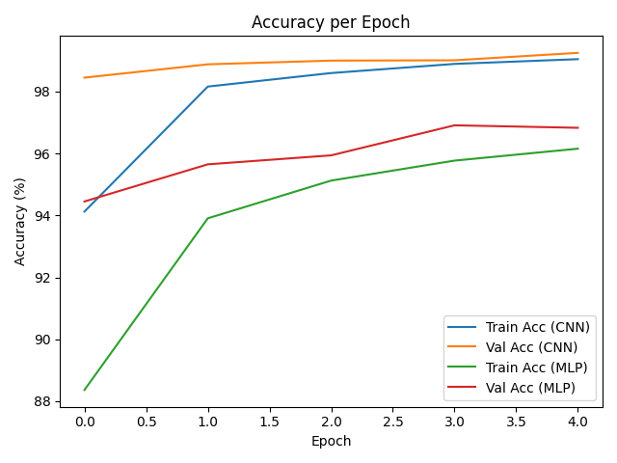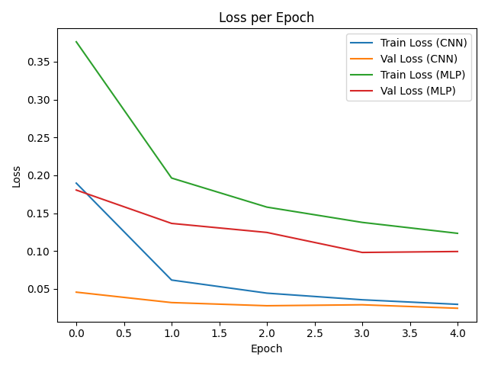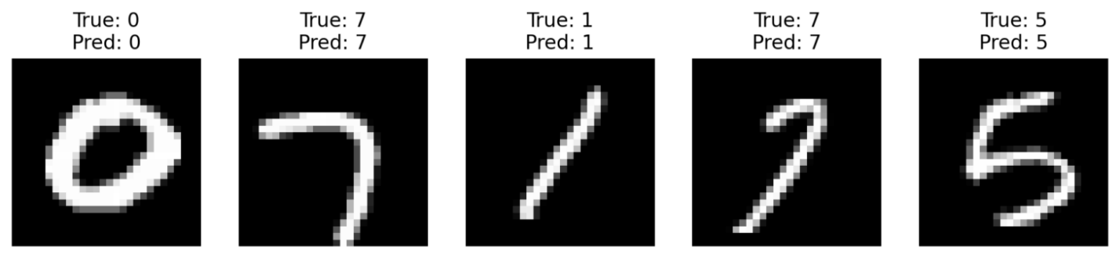
Figure 3: Predictions on random MNIST test images.

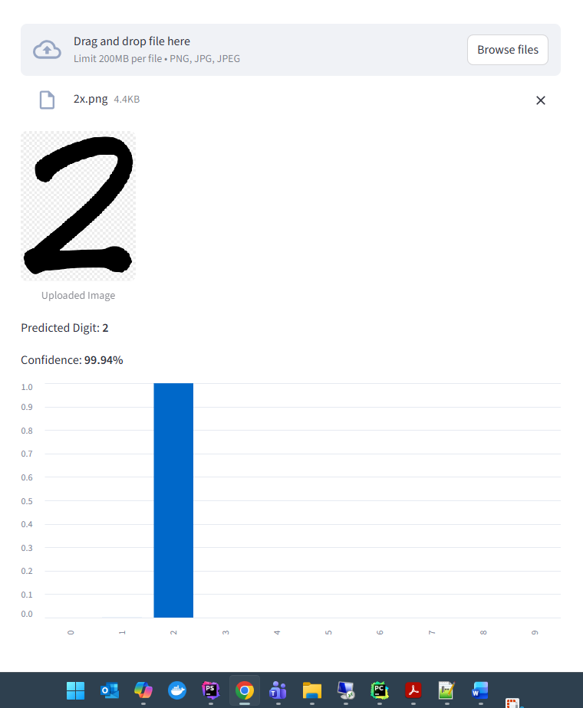
Figure 4: Predictions on custom handwritten digits.

